**PROJECT REPORT TEMPLATE**

**1. INTRODUCTION:**

**1.1 OVERVIEW:**

**Define you event management process:**

* Before you start building an event management system I salesforce, you need to define your event management process. Set up your salesforce environment :
* Once you have a clear understanding of your event management process, you can set up your salesforce environment. T his will involve creating custom objects, fields, workflow to support your event management process .

**1.2 PURPOSE:**

* You can use salesforce analytics tools to analyse event data, such as attendance rates, feedbackscores, revenue generated
* This will give you insights into the effectiveness of your event management process and help you make data-driven decision

**2. PROBLBM DEFINITION &DESIGN THINKING**

**2.1 EMPATHY MAP:**

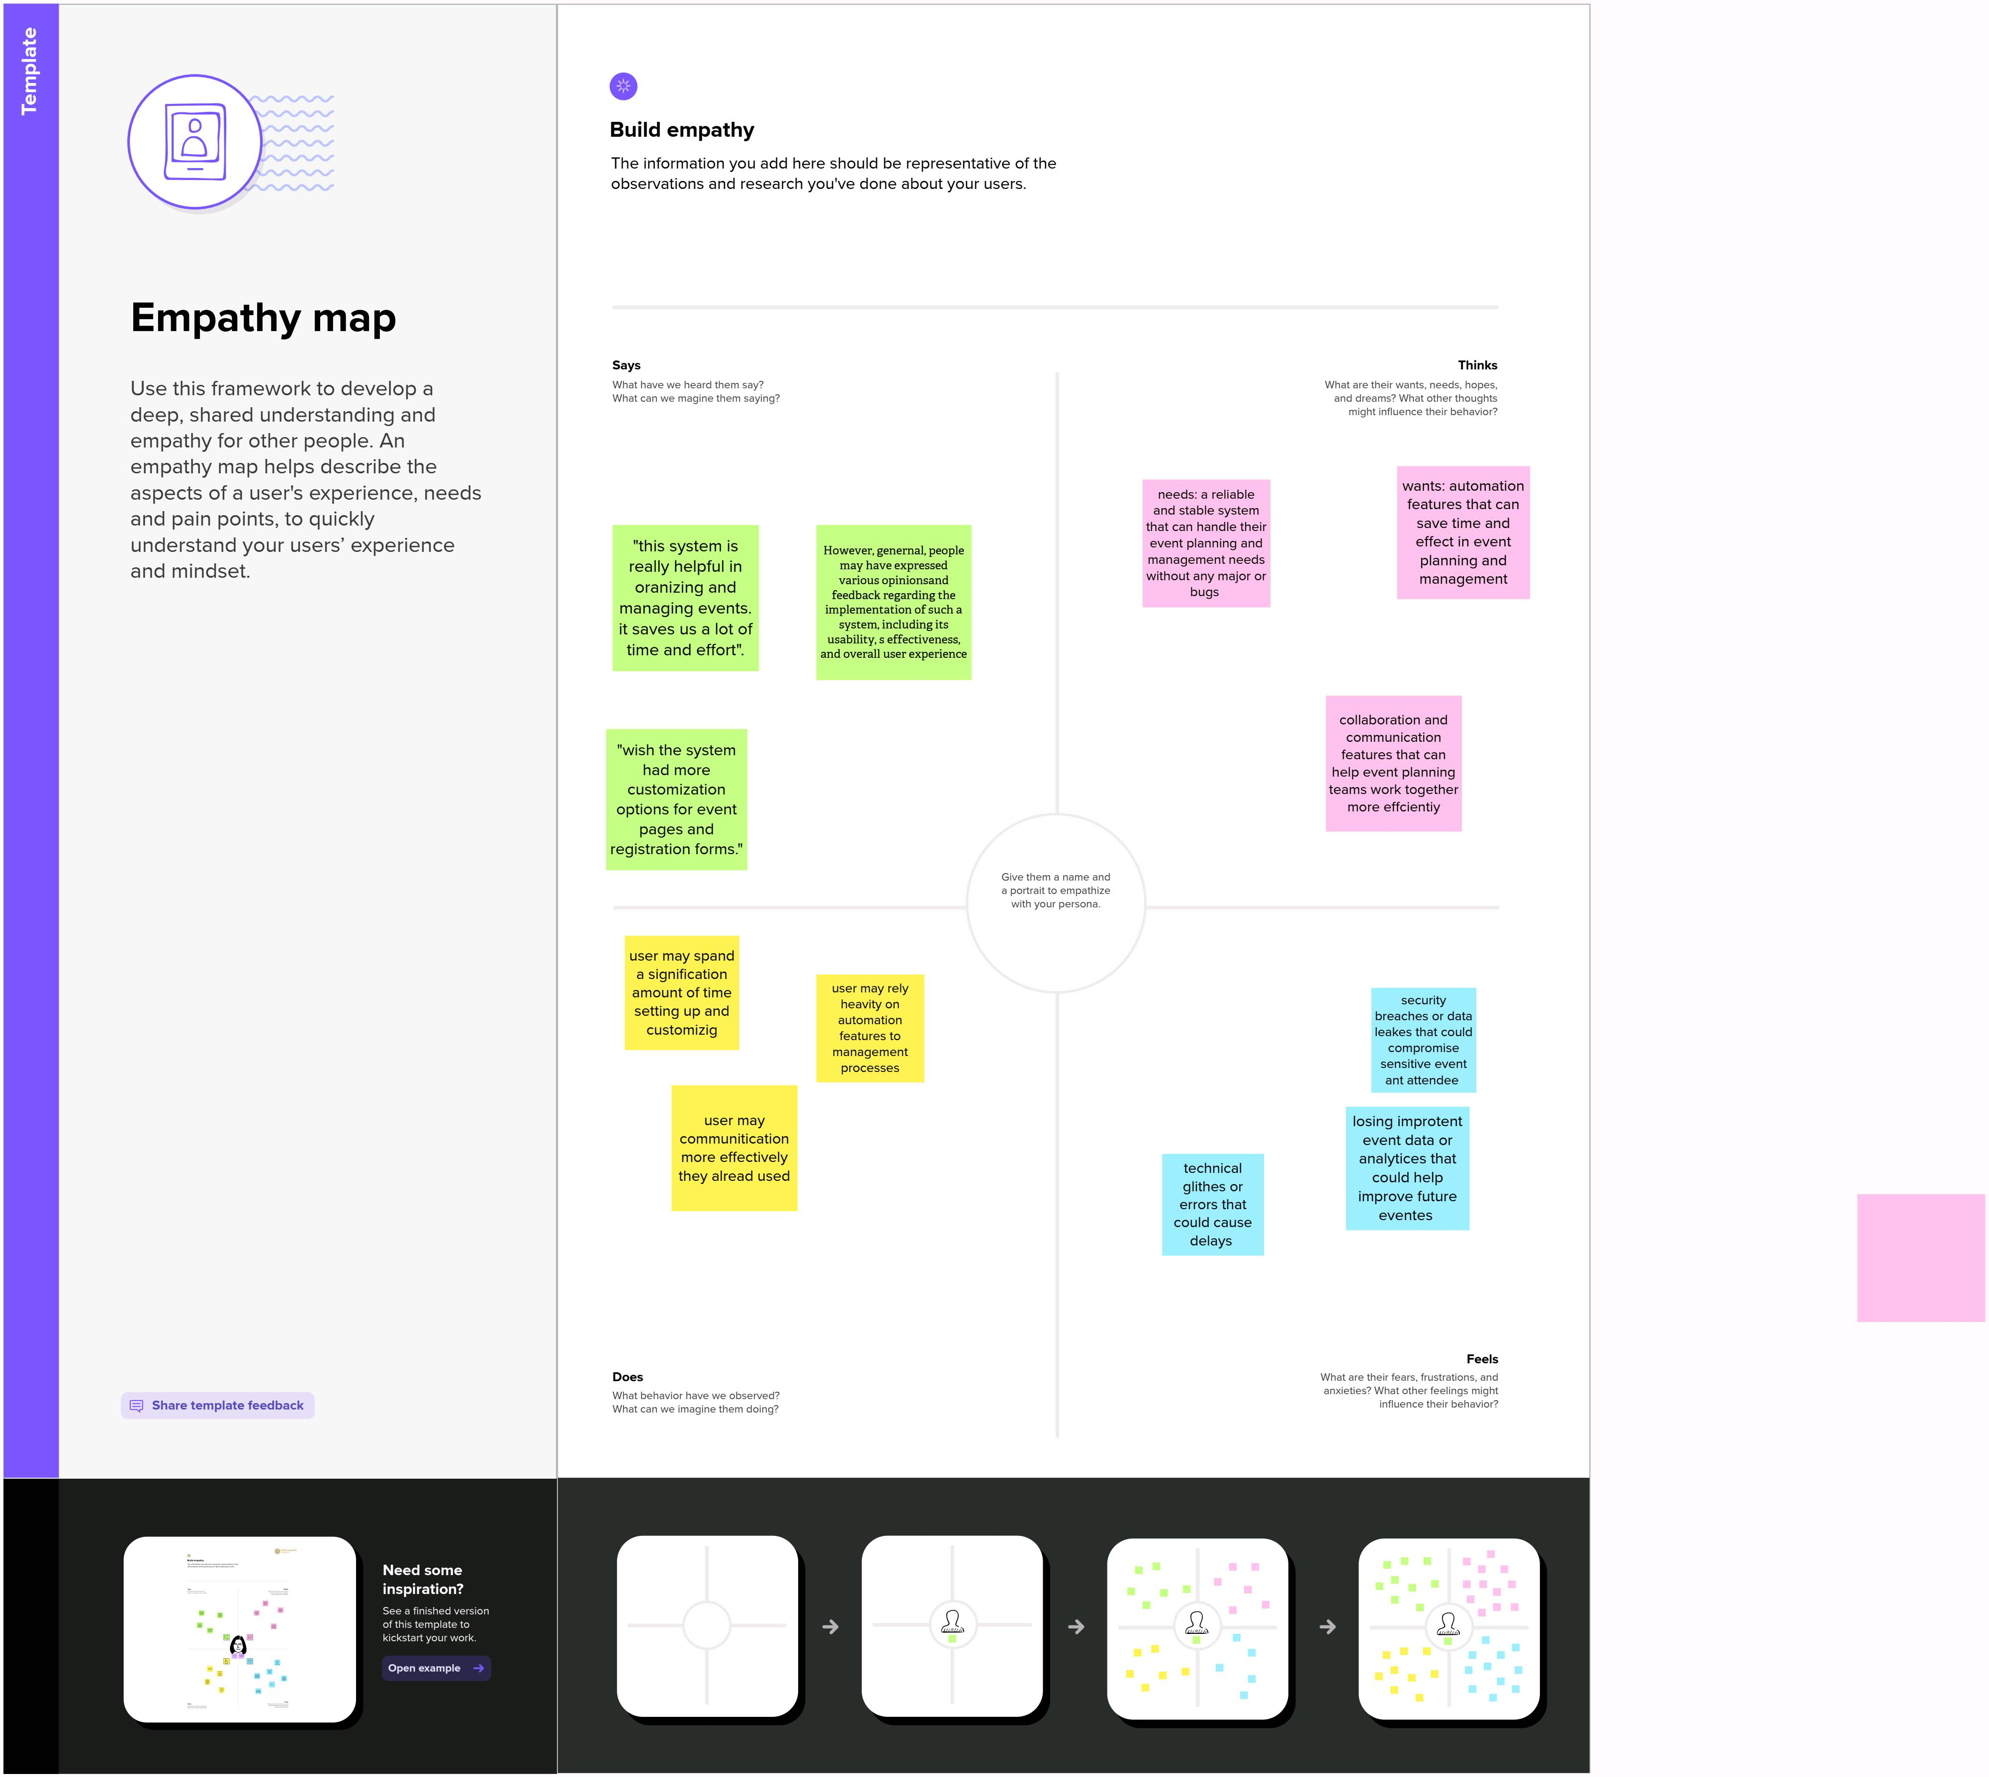

**2.2 Ideation & Brainstorming Map**

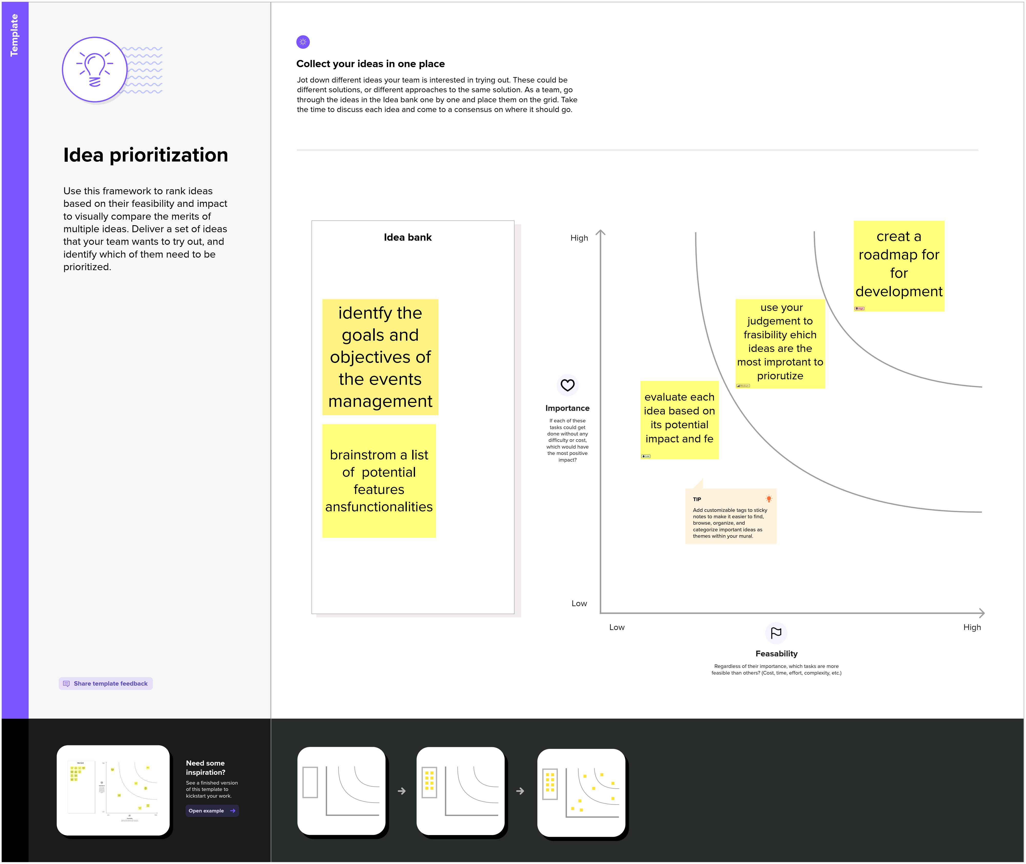

**3) 3.1 Data Model:**

**3.1 Data Model**

|  |  |
| --- | --- |
| Object name | Fields in the Object |
| Object 1 | |  |  | | --- | --- | | Field label | Data type | | City | Text | |
| Object 2 | |  |  | | --- | --- | | Field label | Data type | | Id | Auto number | |
| Object 3 | |  |  | | --- | --- | | Field label | Data type | | Event | Master –detail Relationship | | Event | Look-up Relationship | |
| Object 4 | |  |  | | --- | --- | | Field label | Data type | | Bio | Text Area | |
| Object 5 | |  |  | | --- | --- | | Field label | Data type | | e-mail | E-mail | | Phone | Phone | | Service provider | Text | | Event | Look-up Relationship | |

**3.2 Activity & Screenshot**

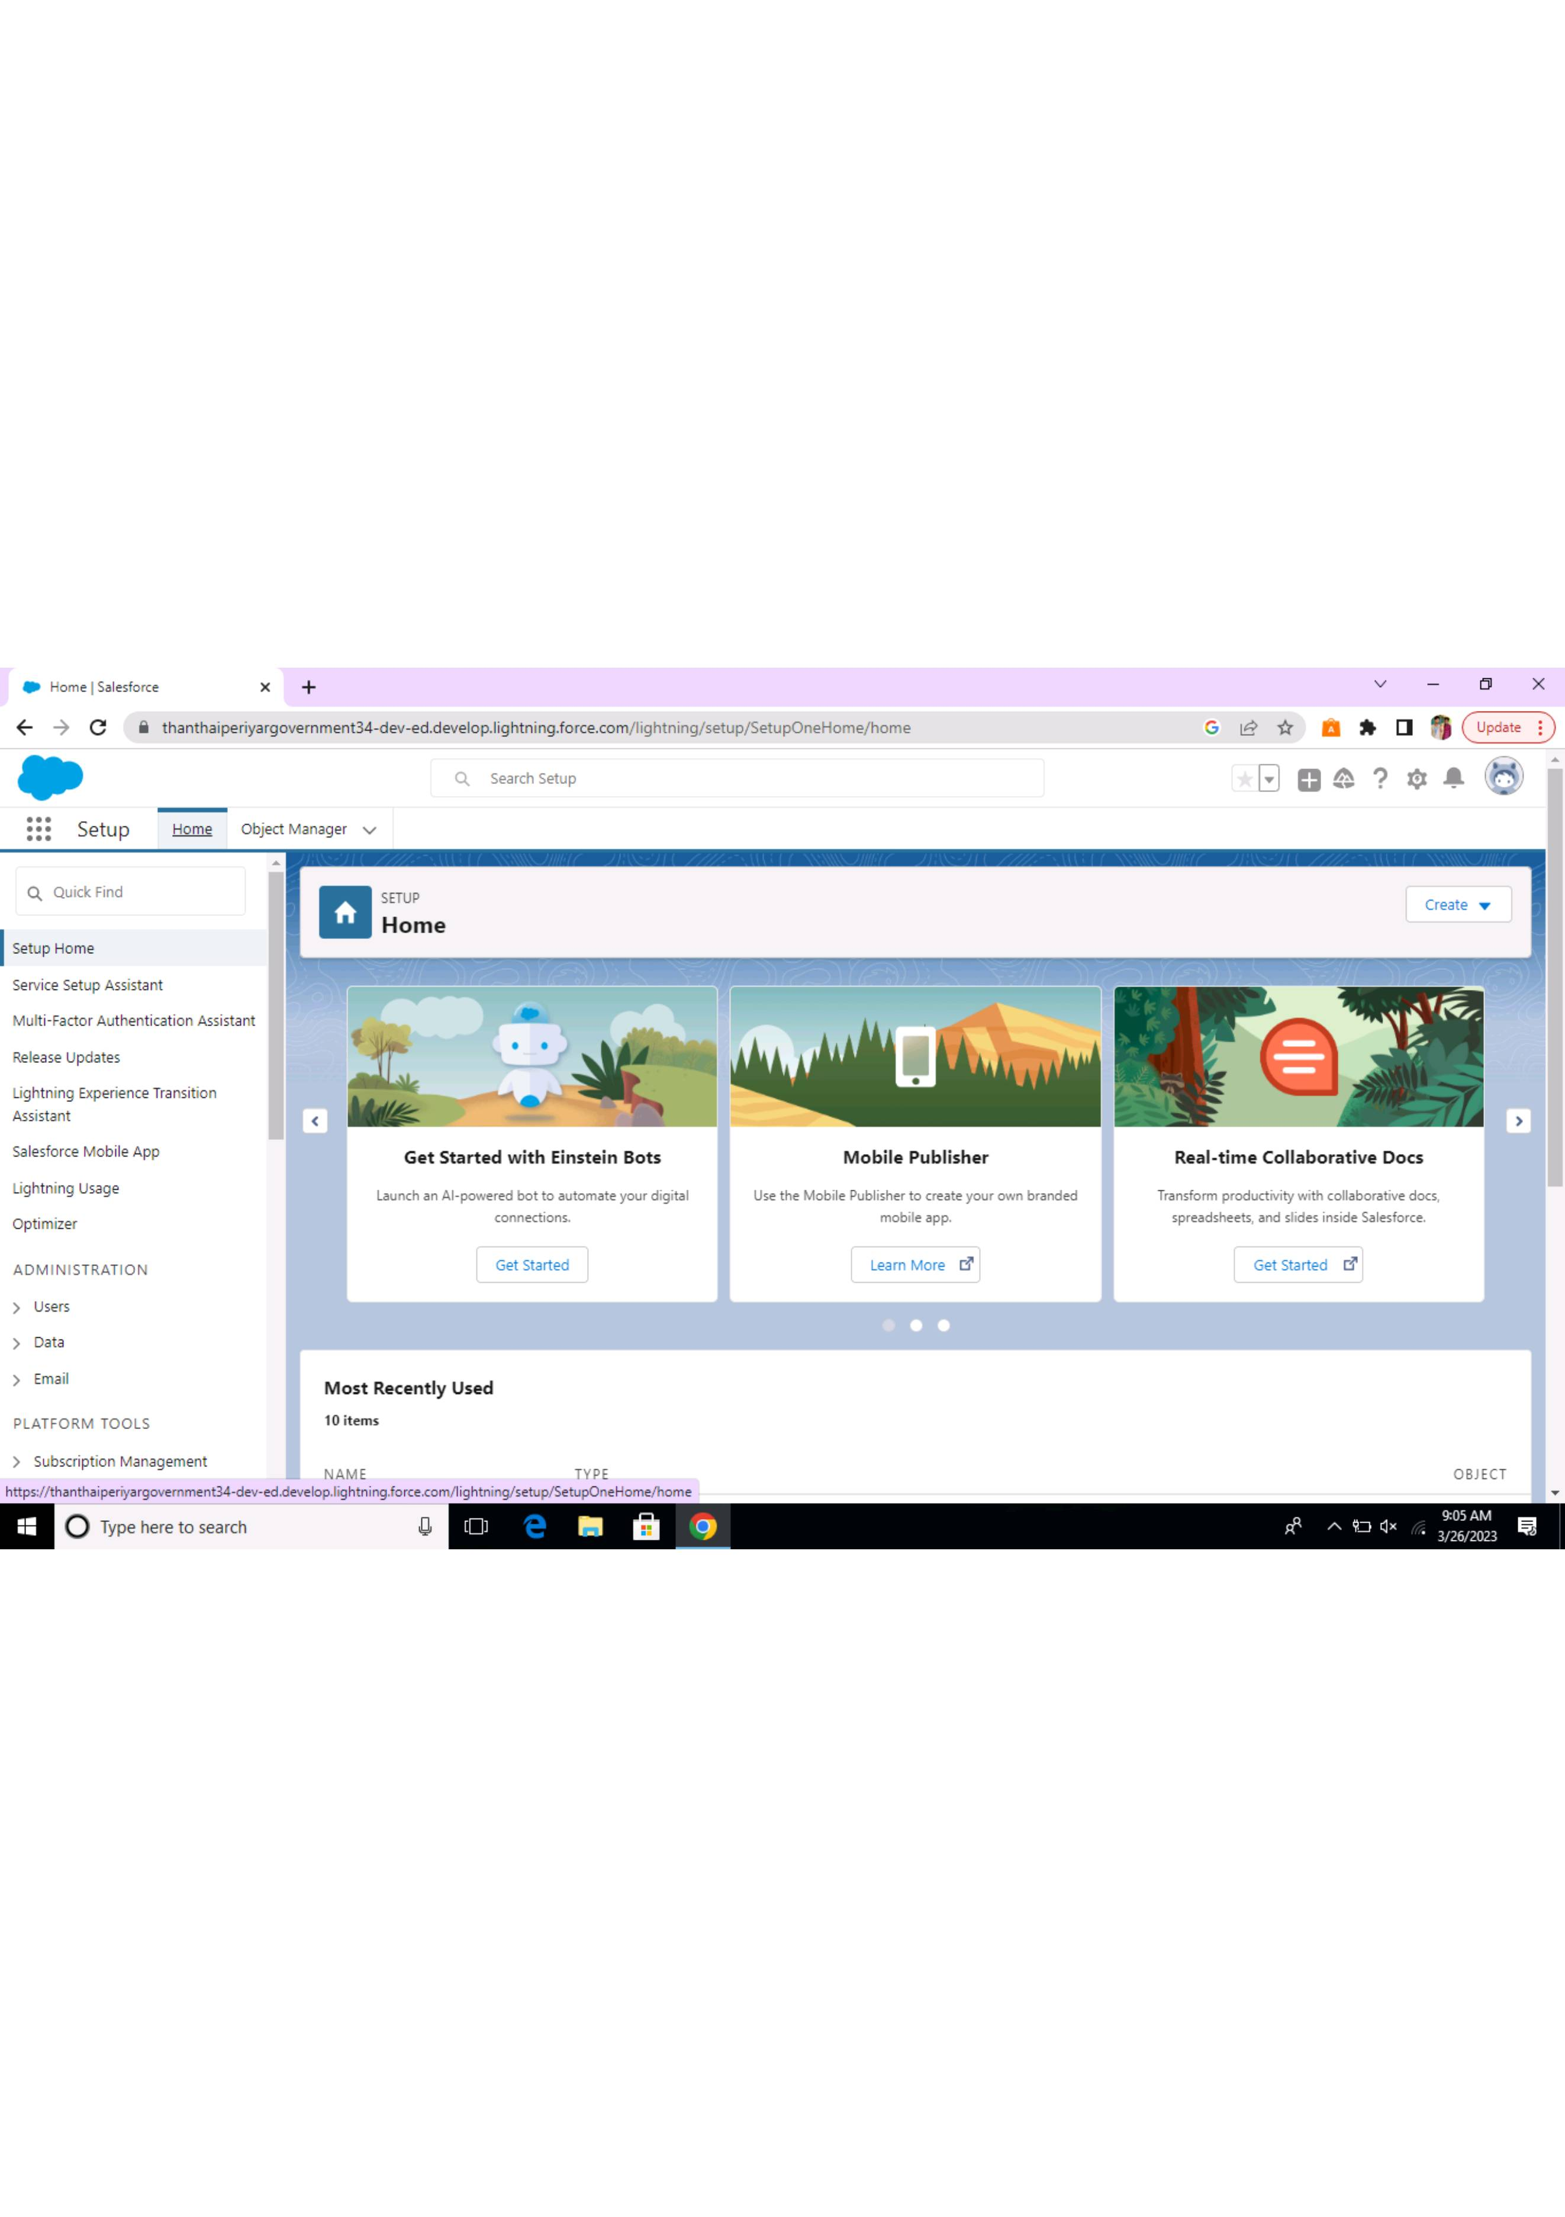 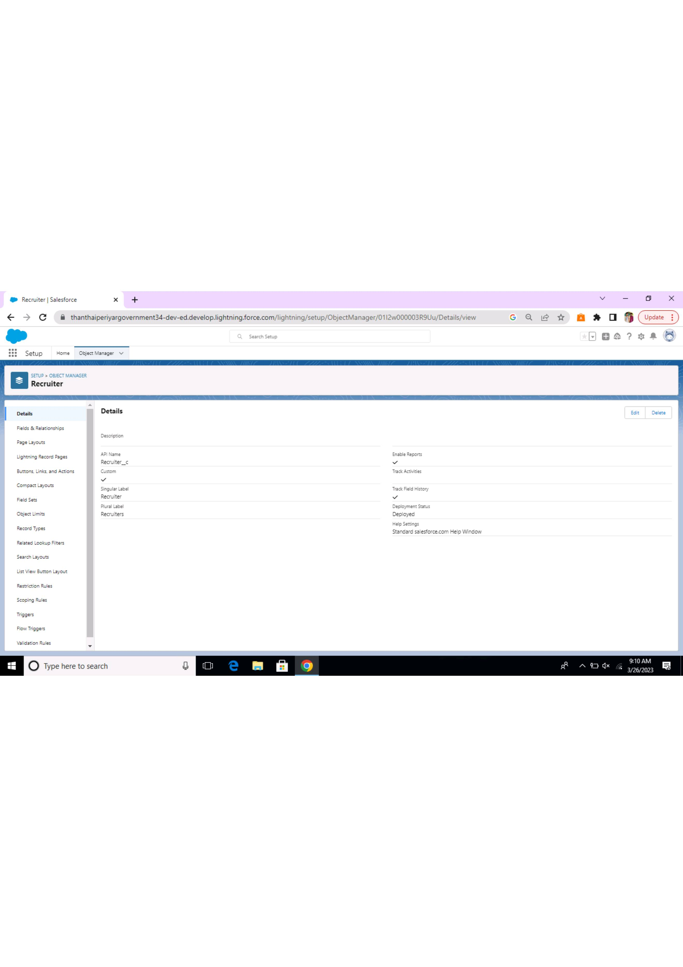

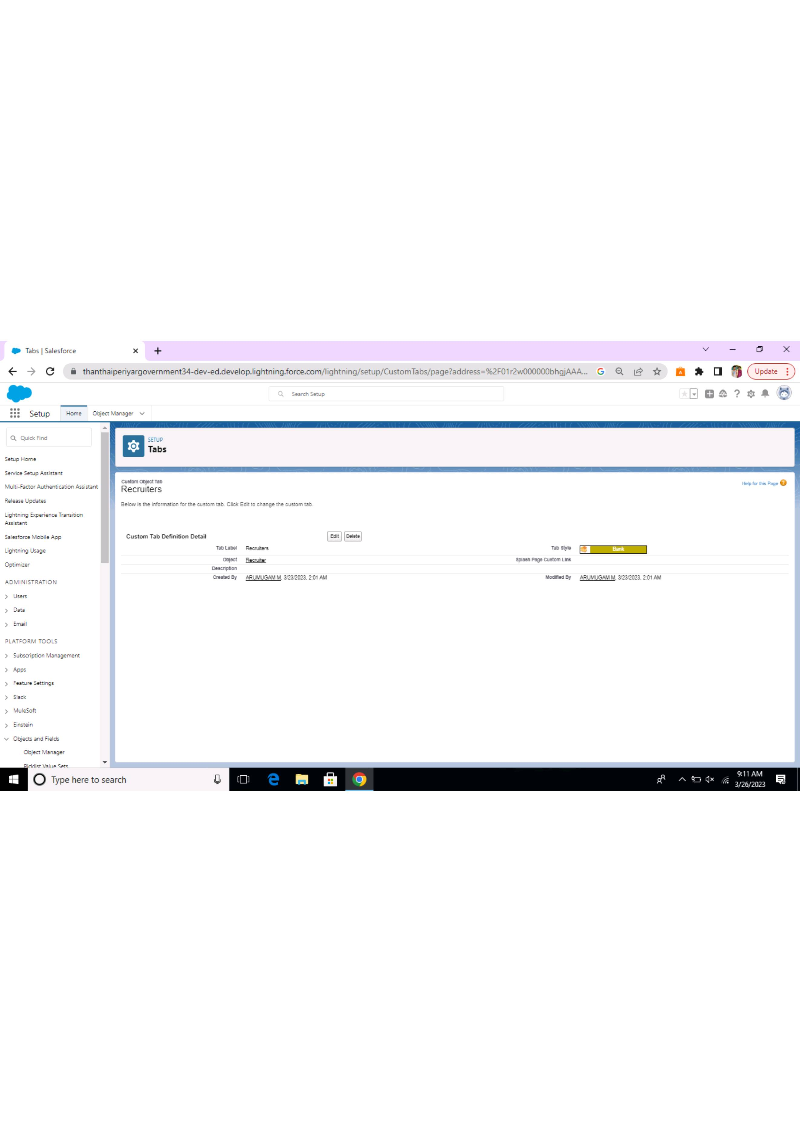 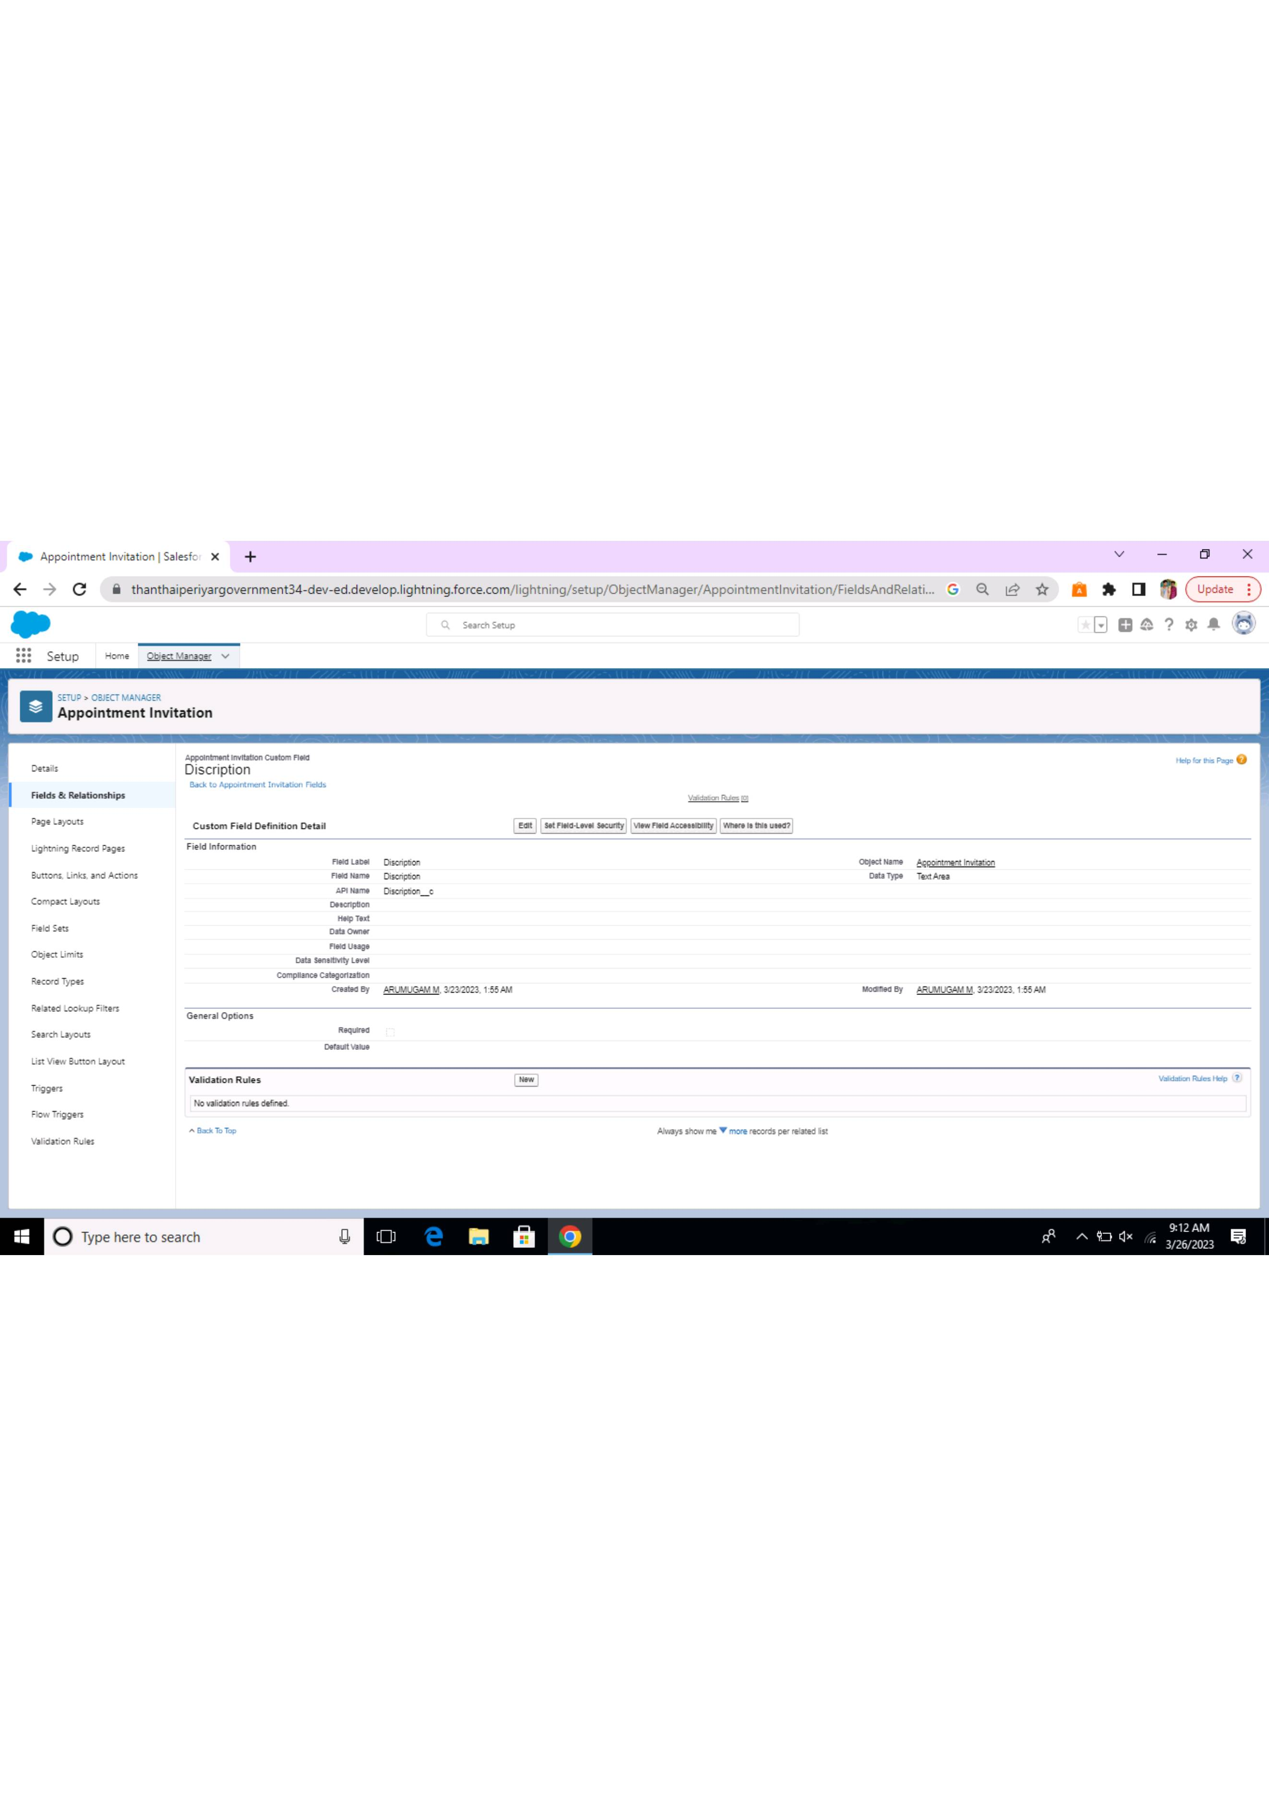

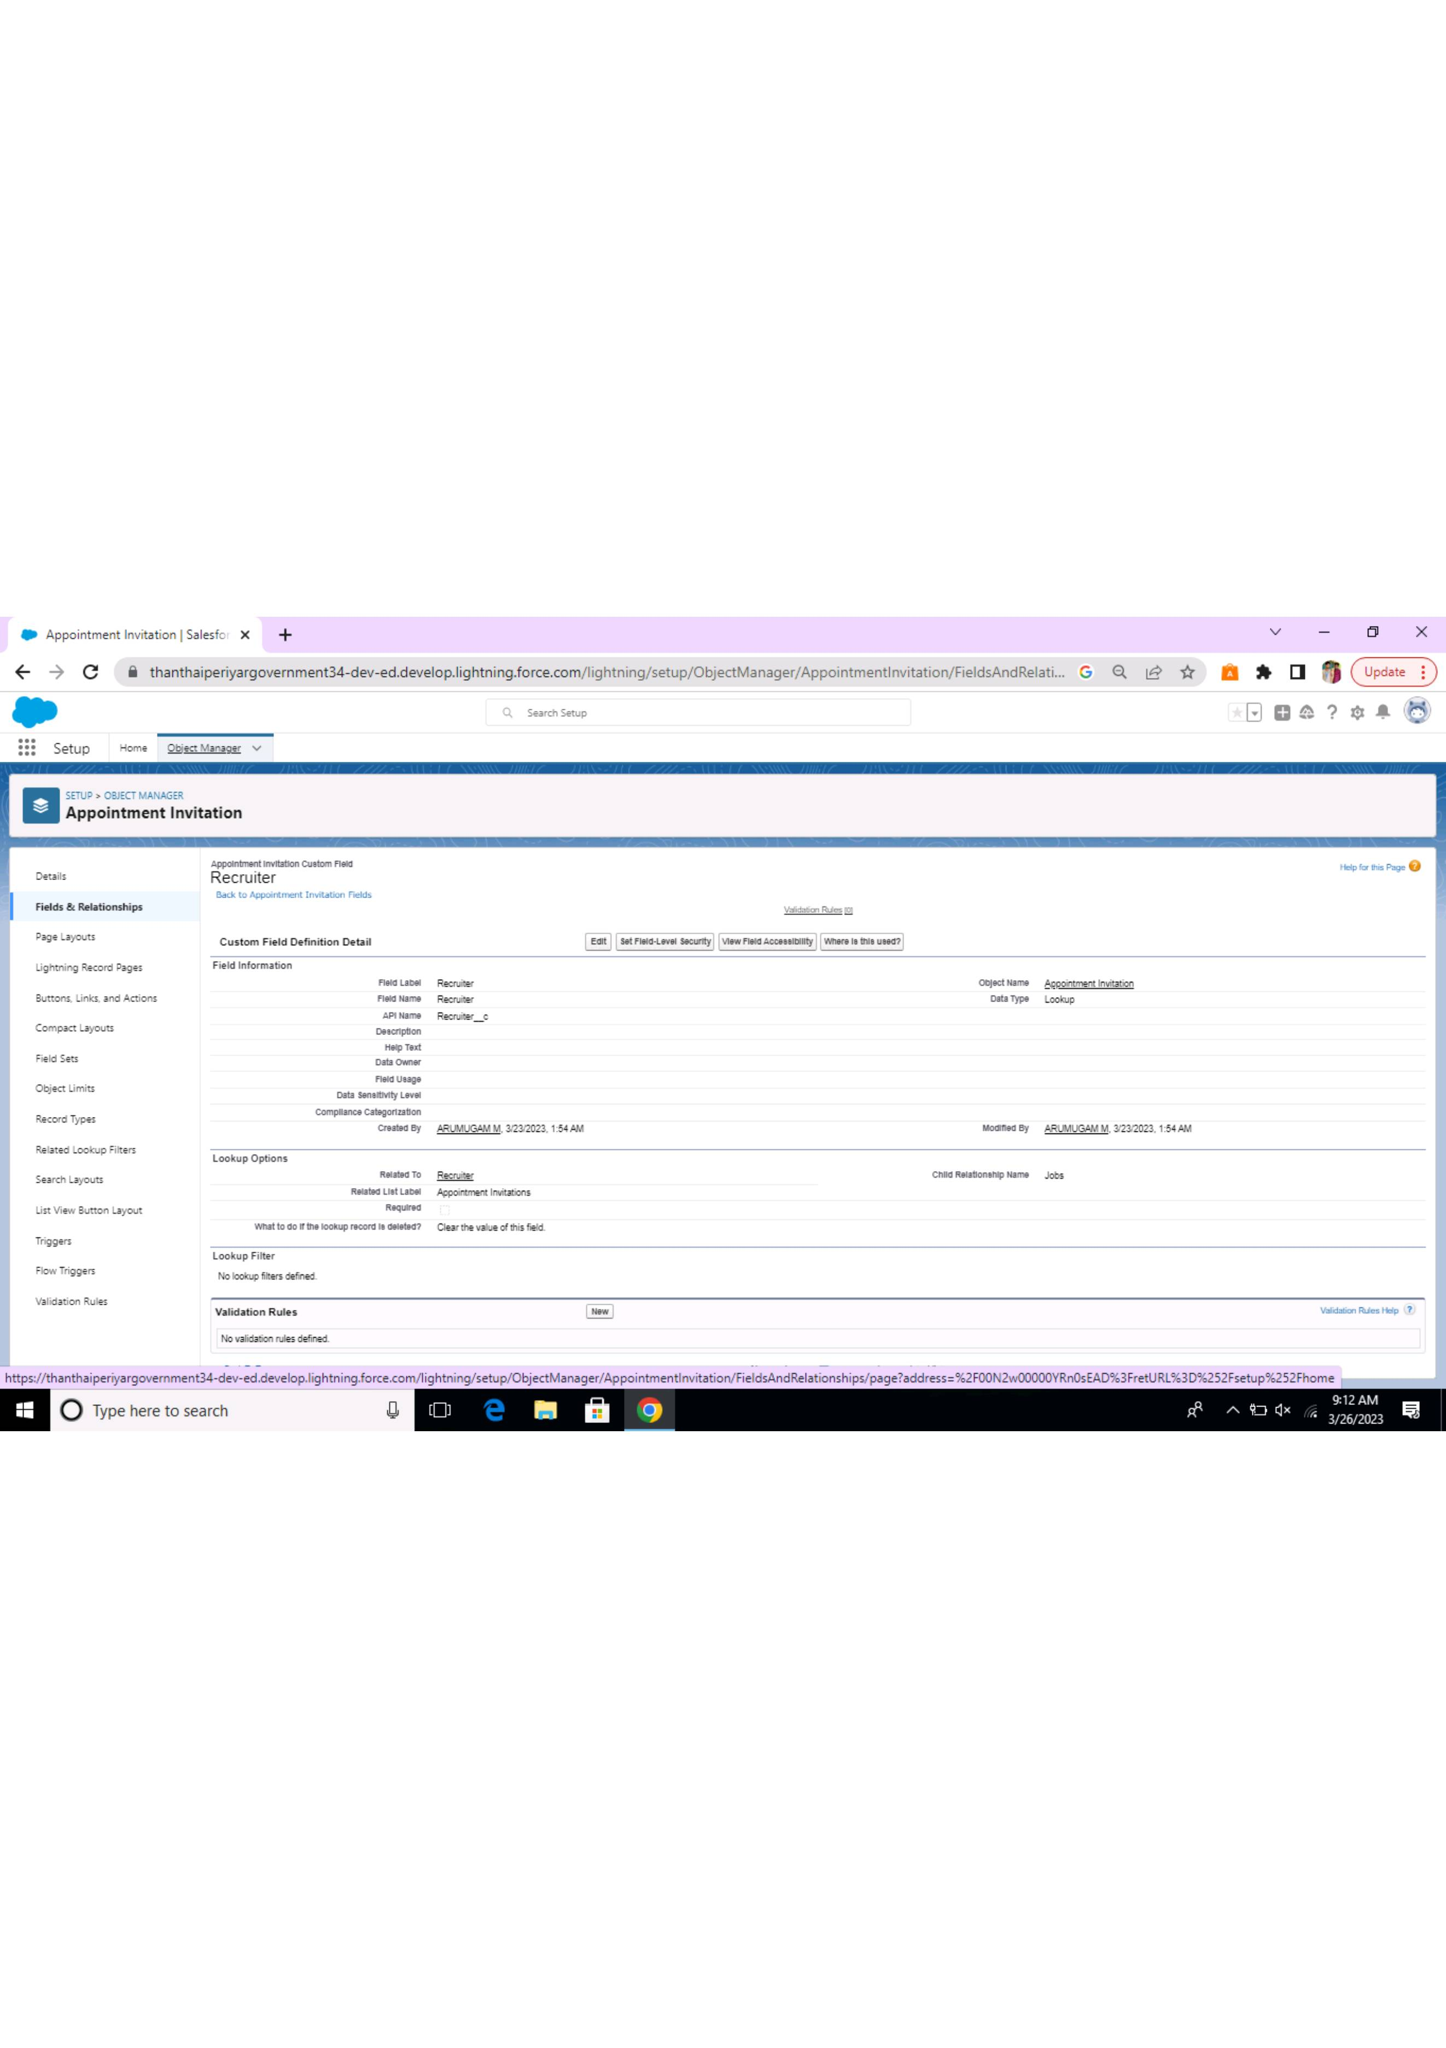 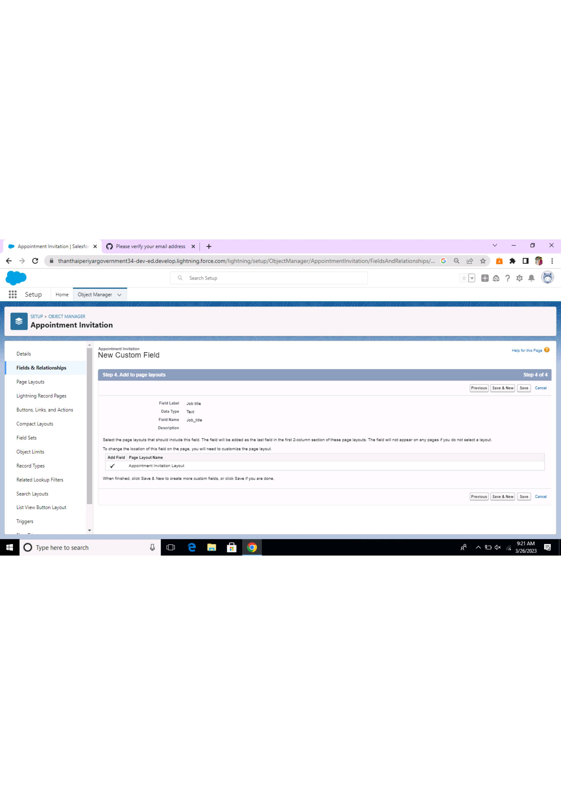

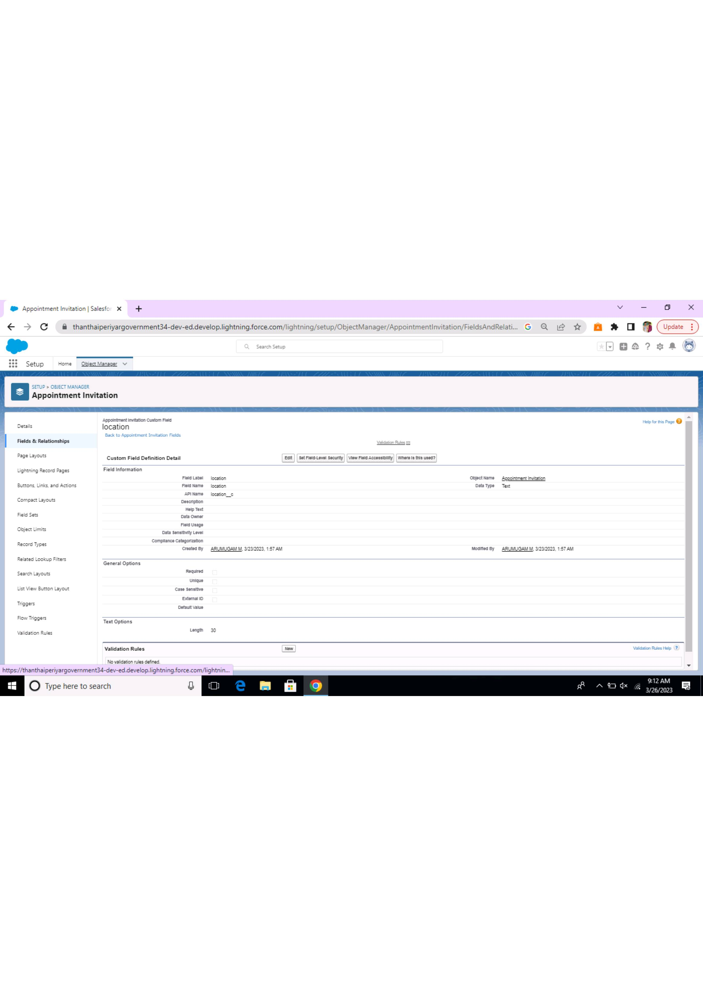 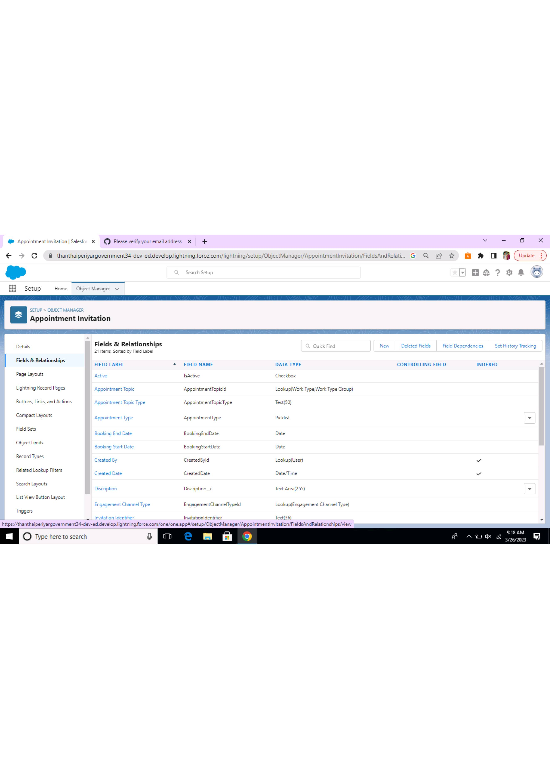

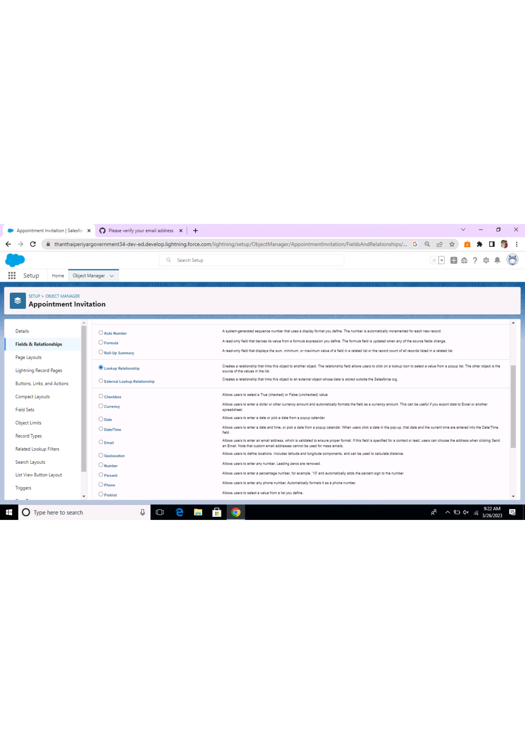 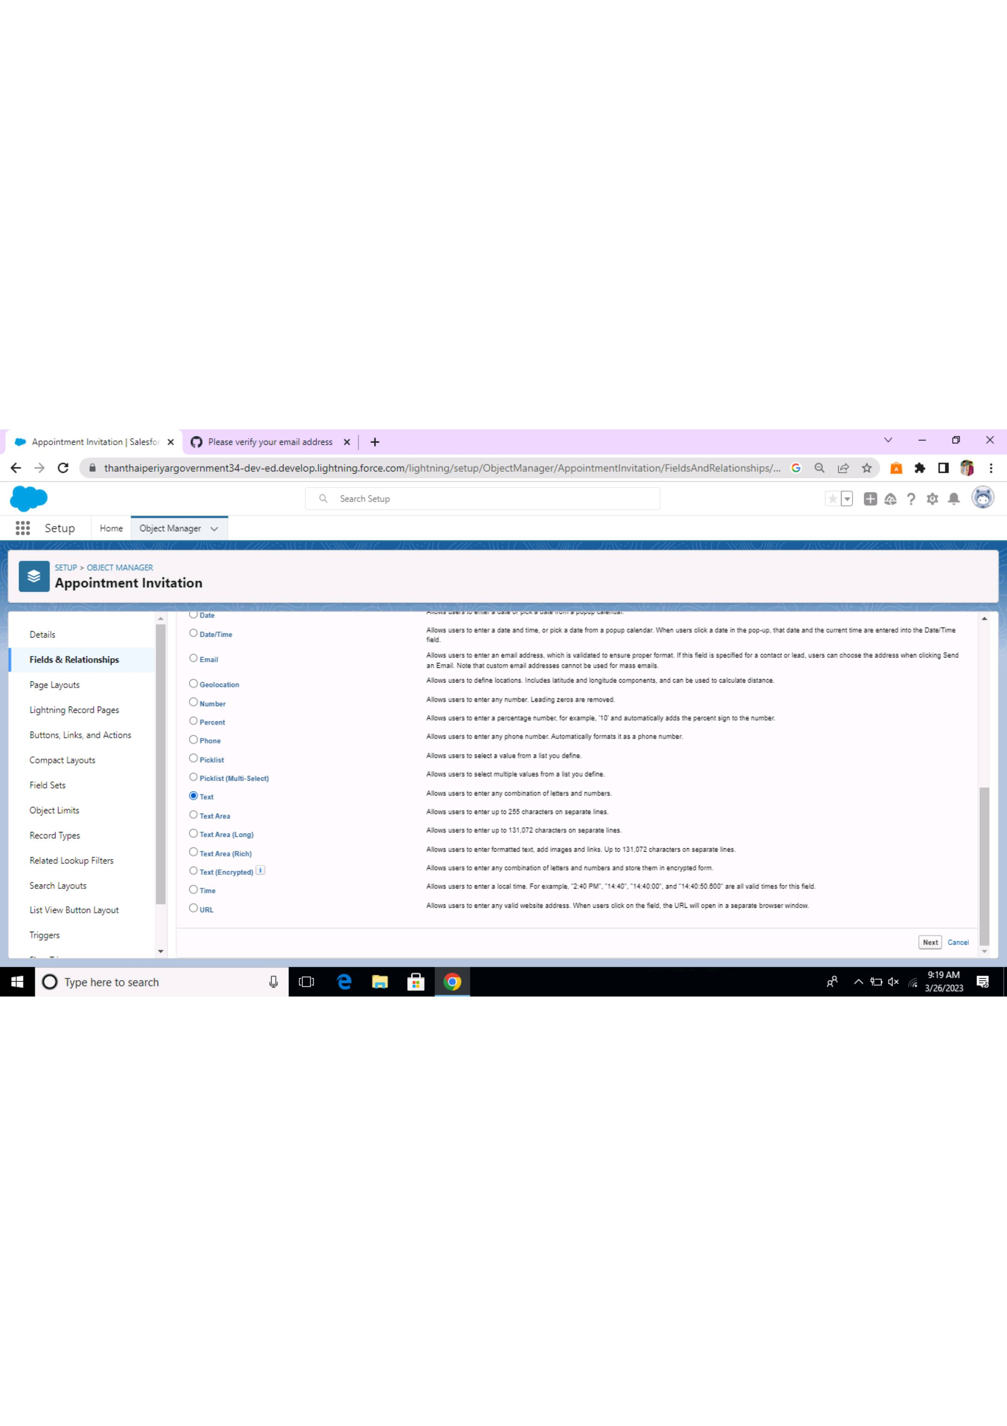

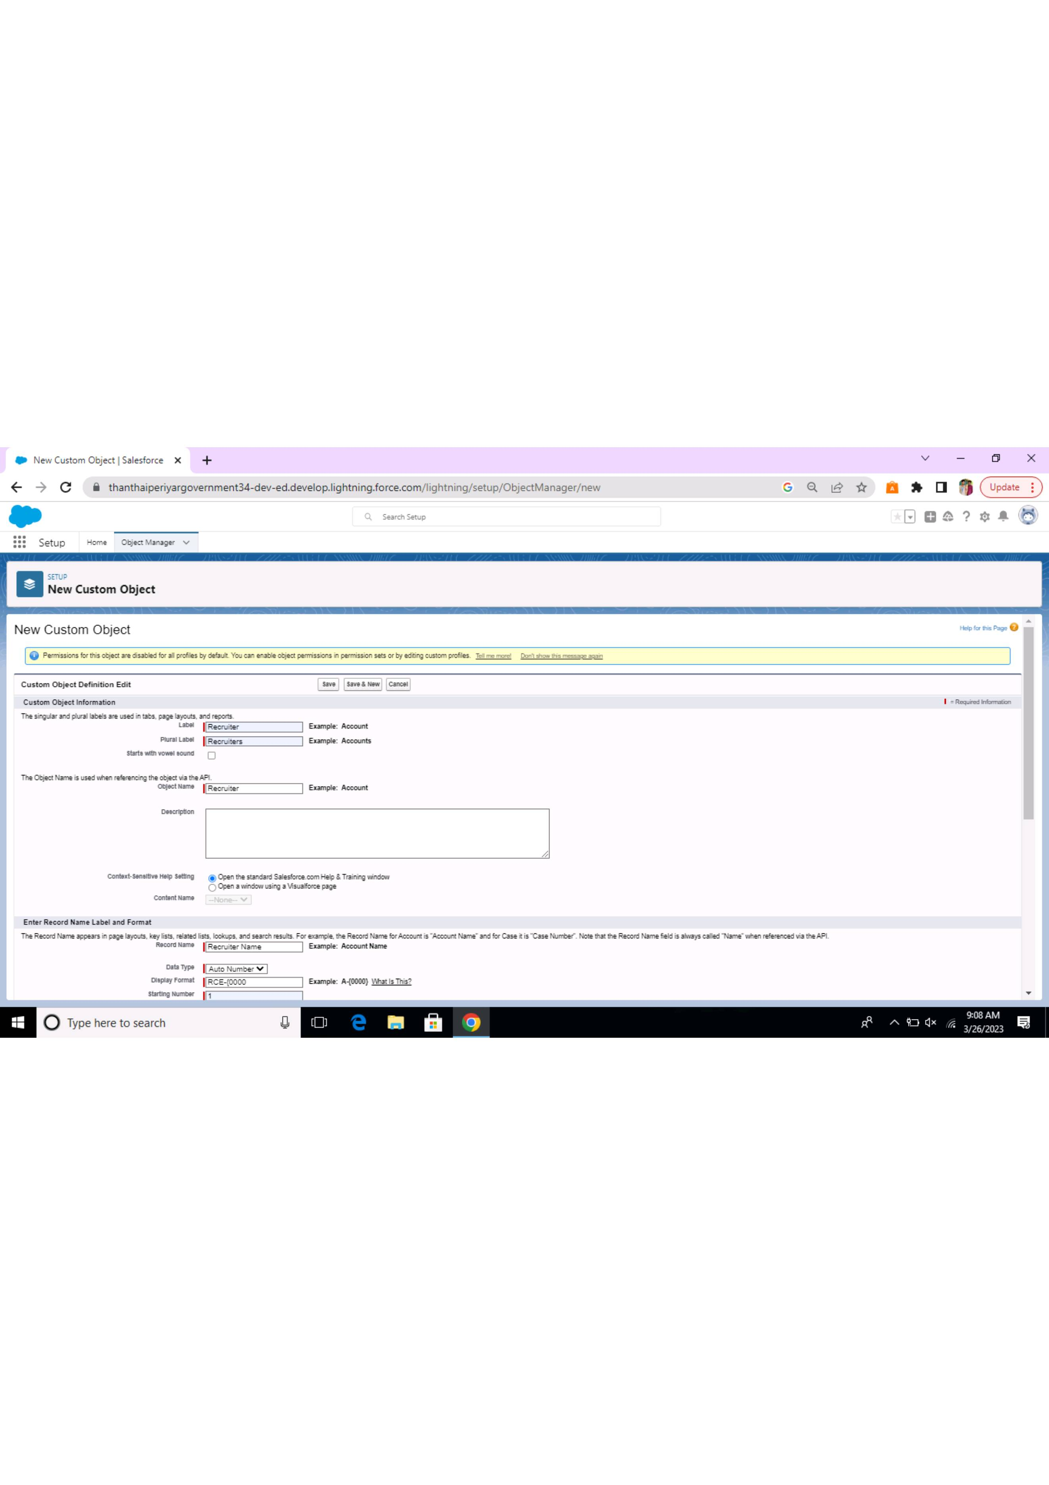 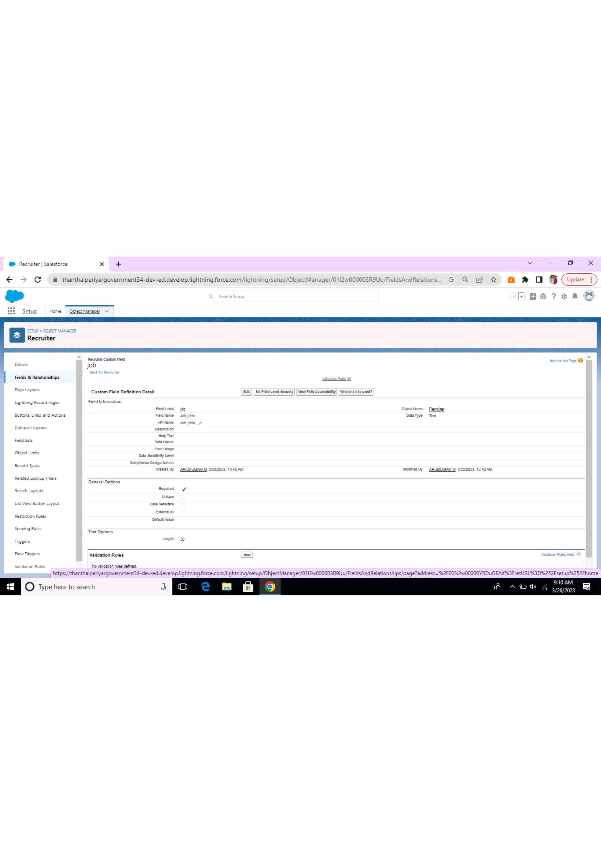

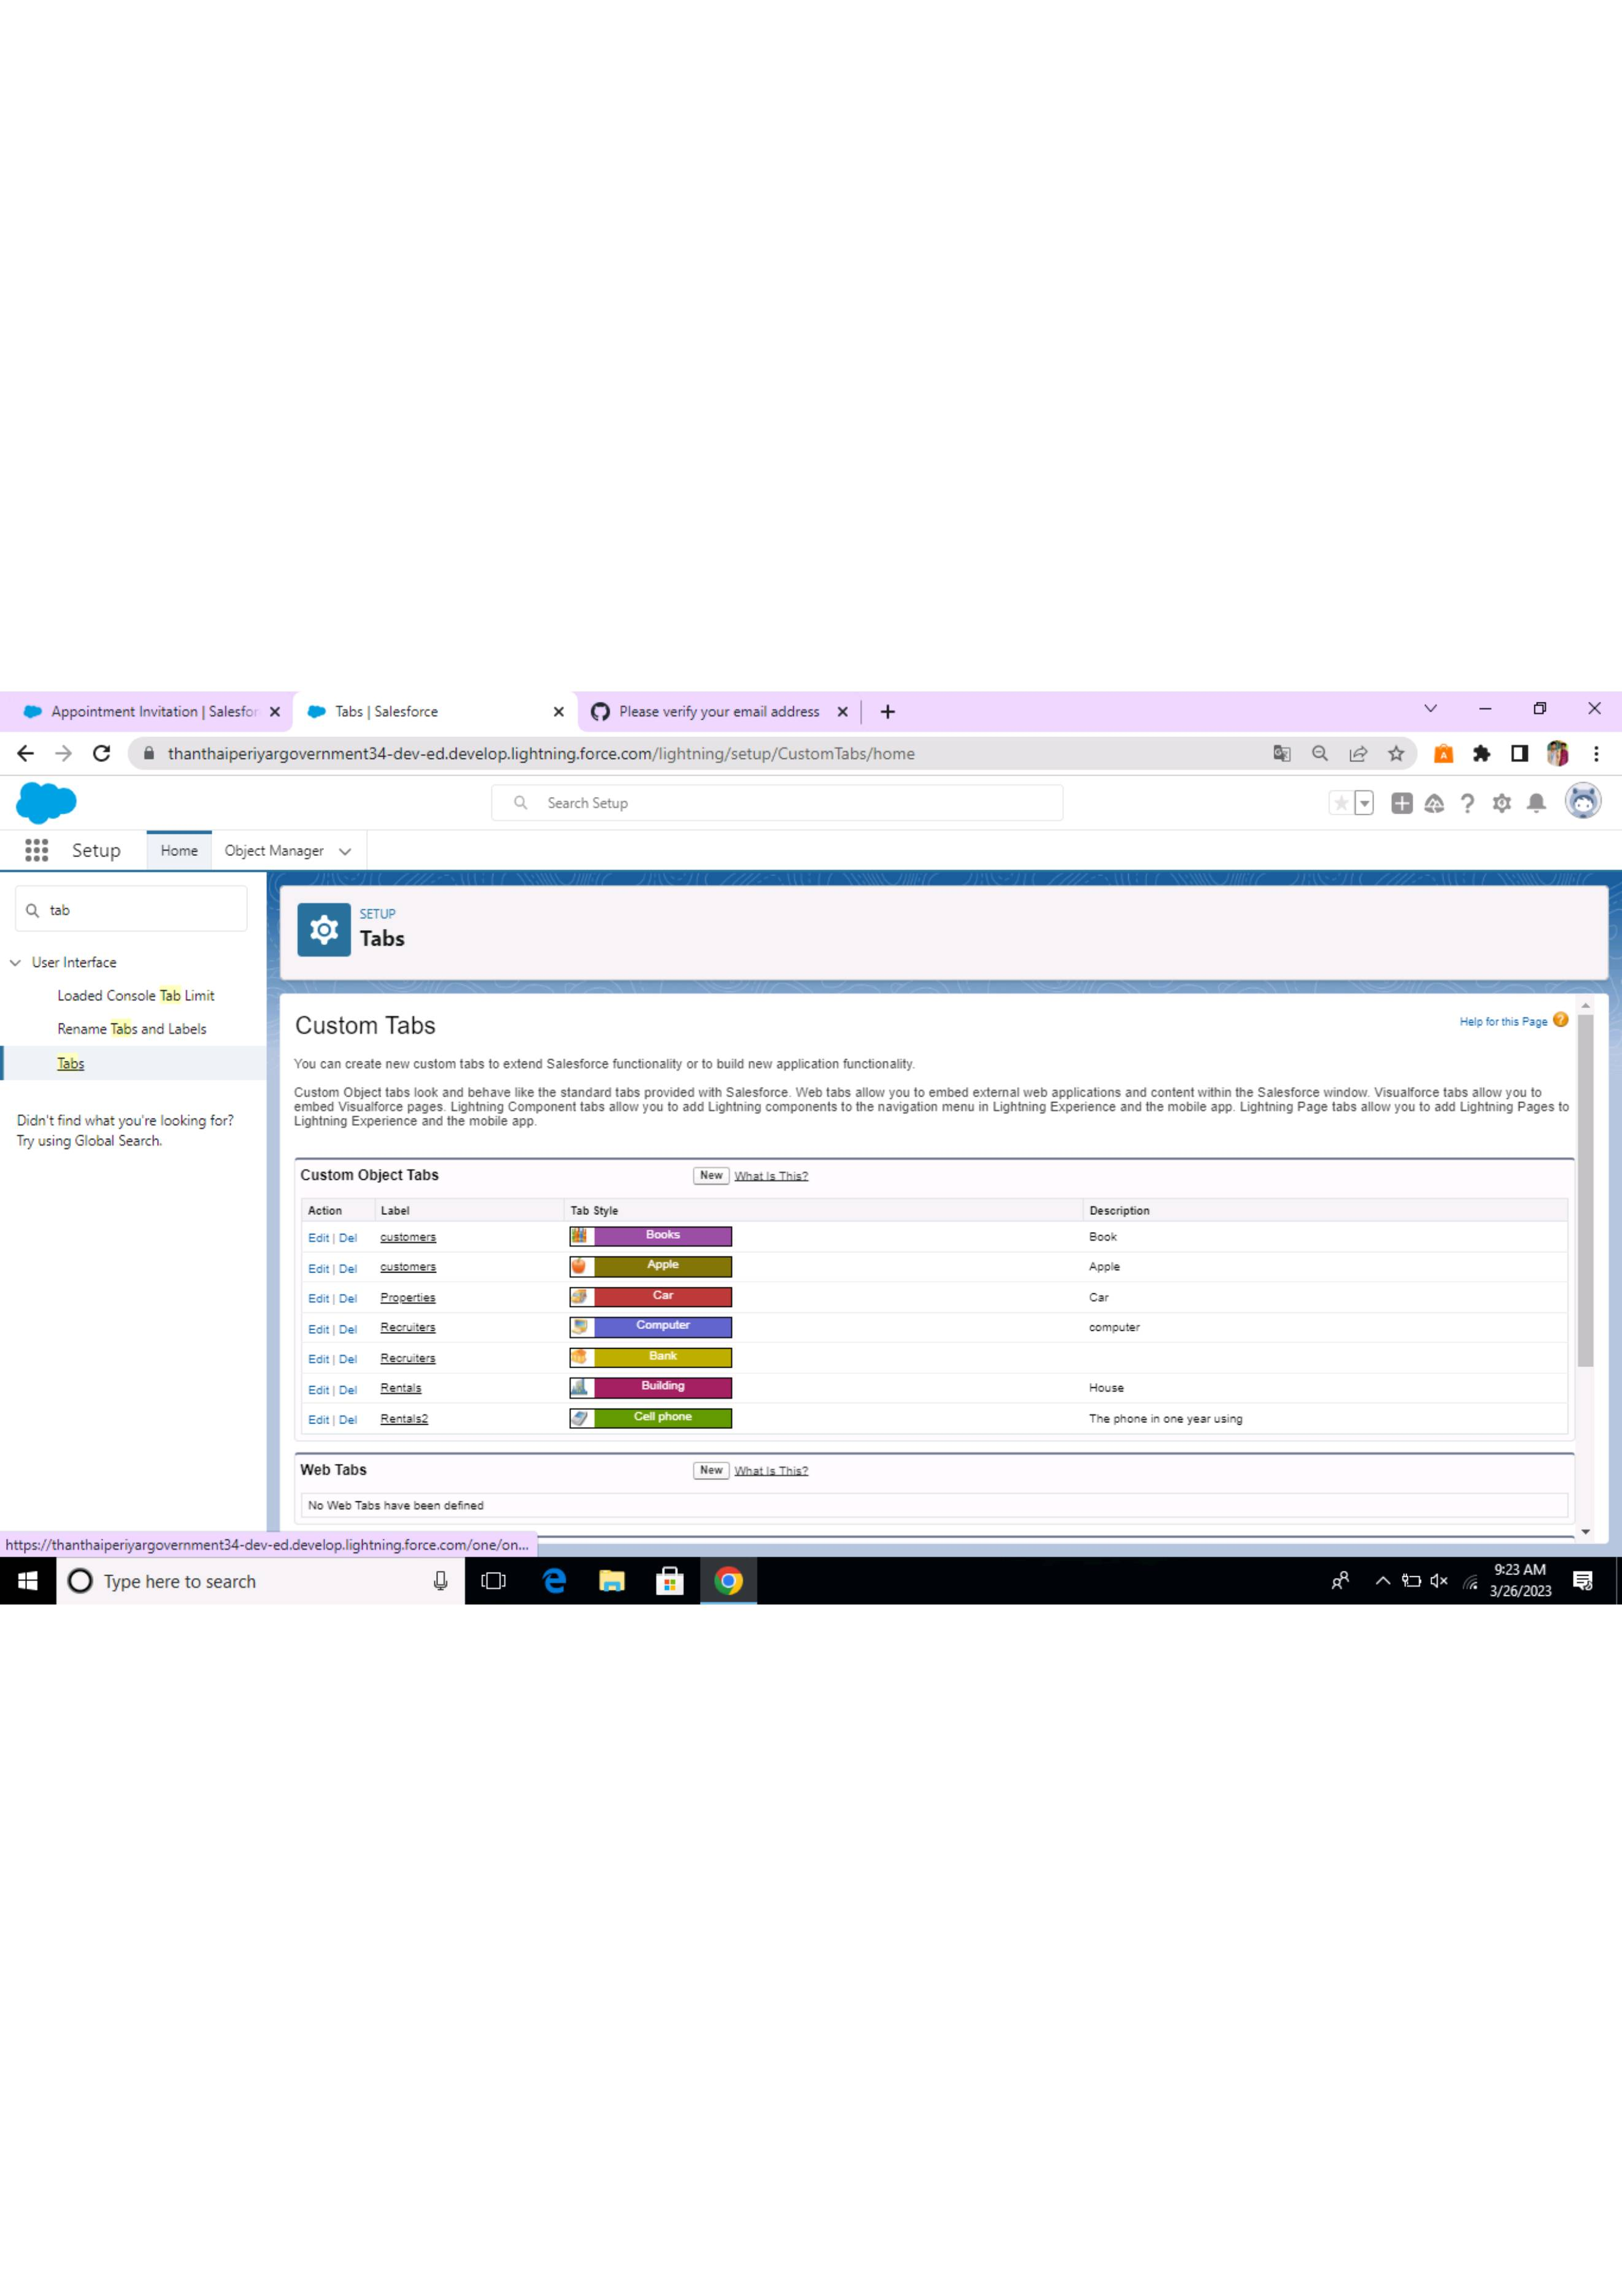 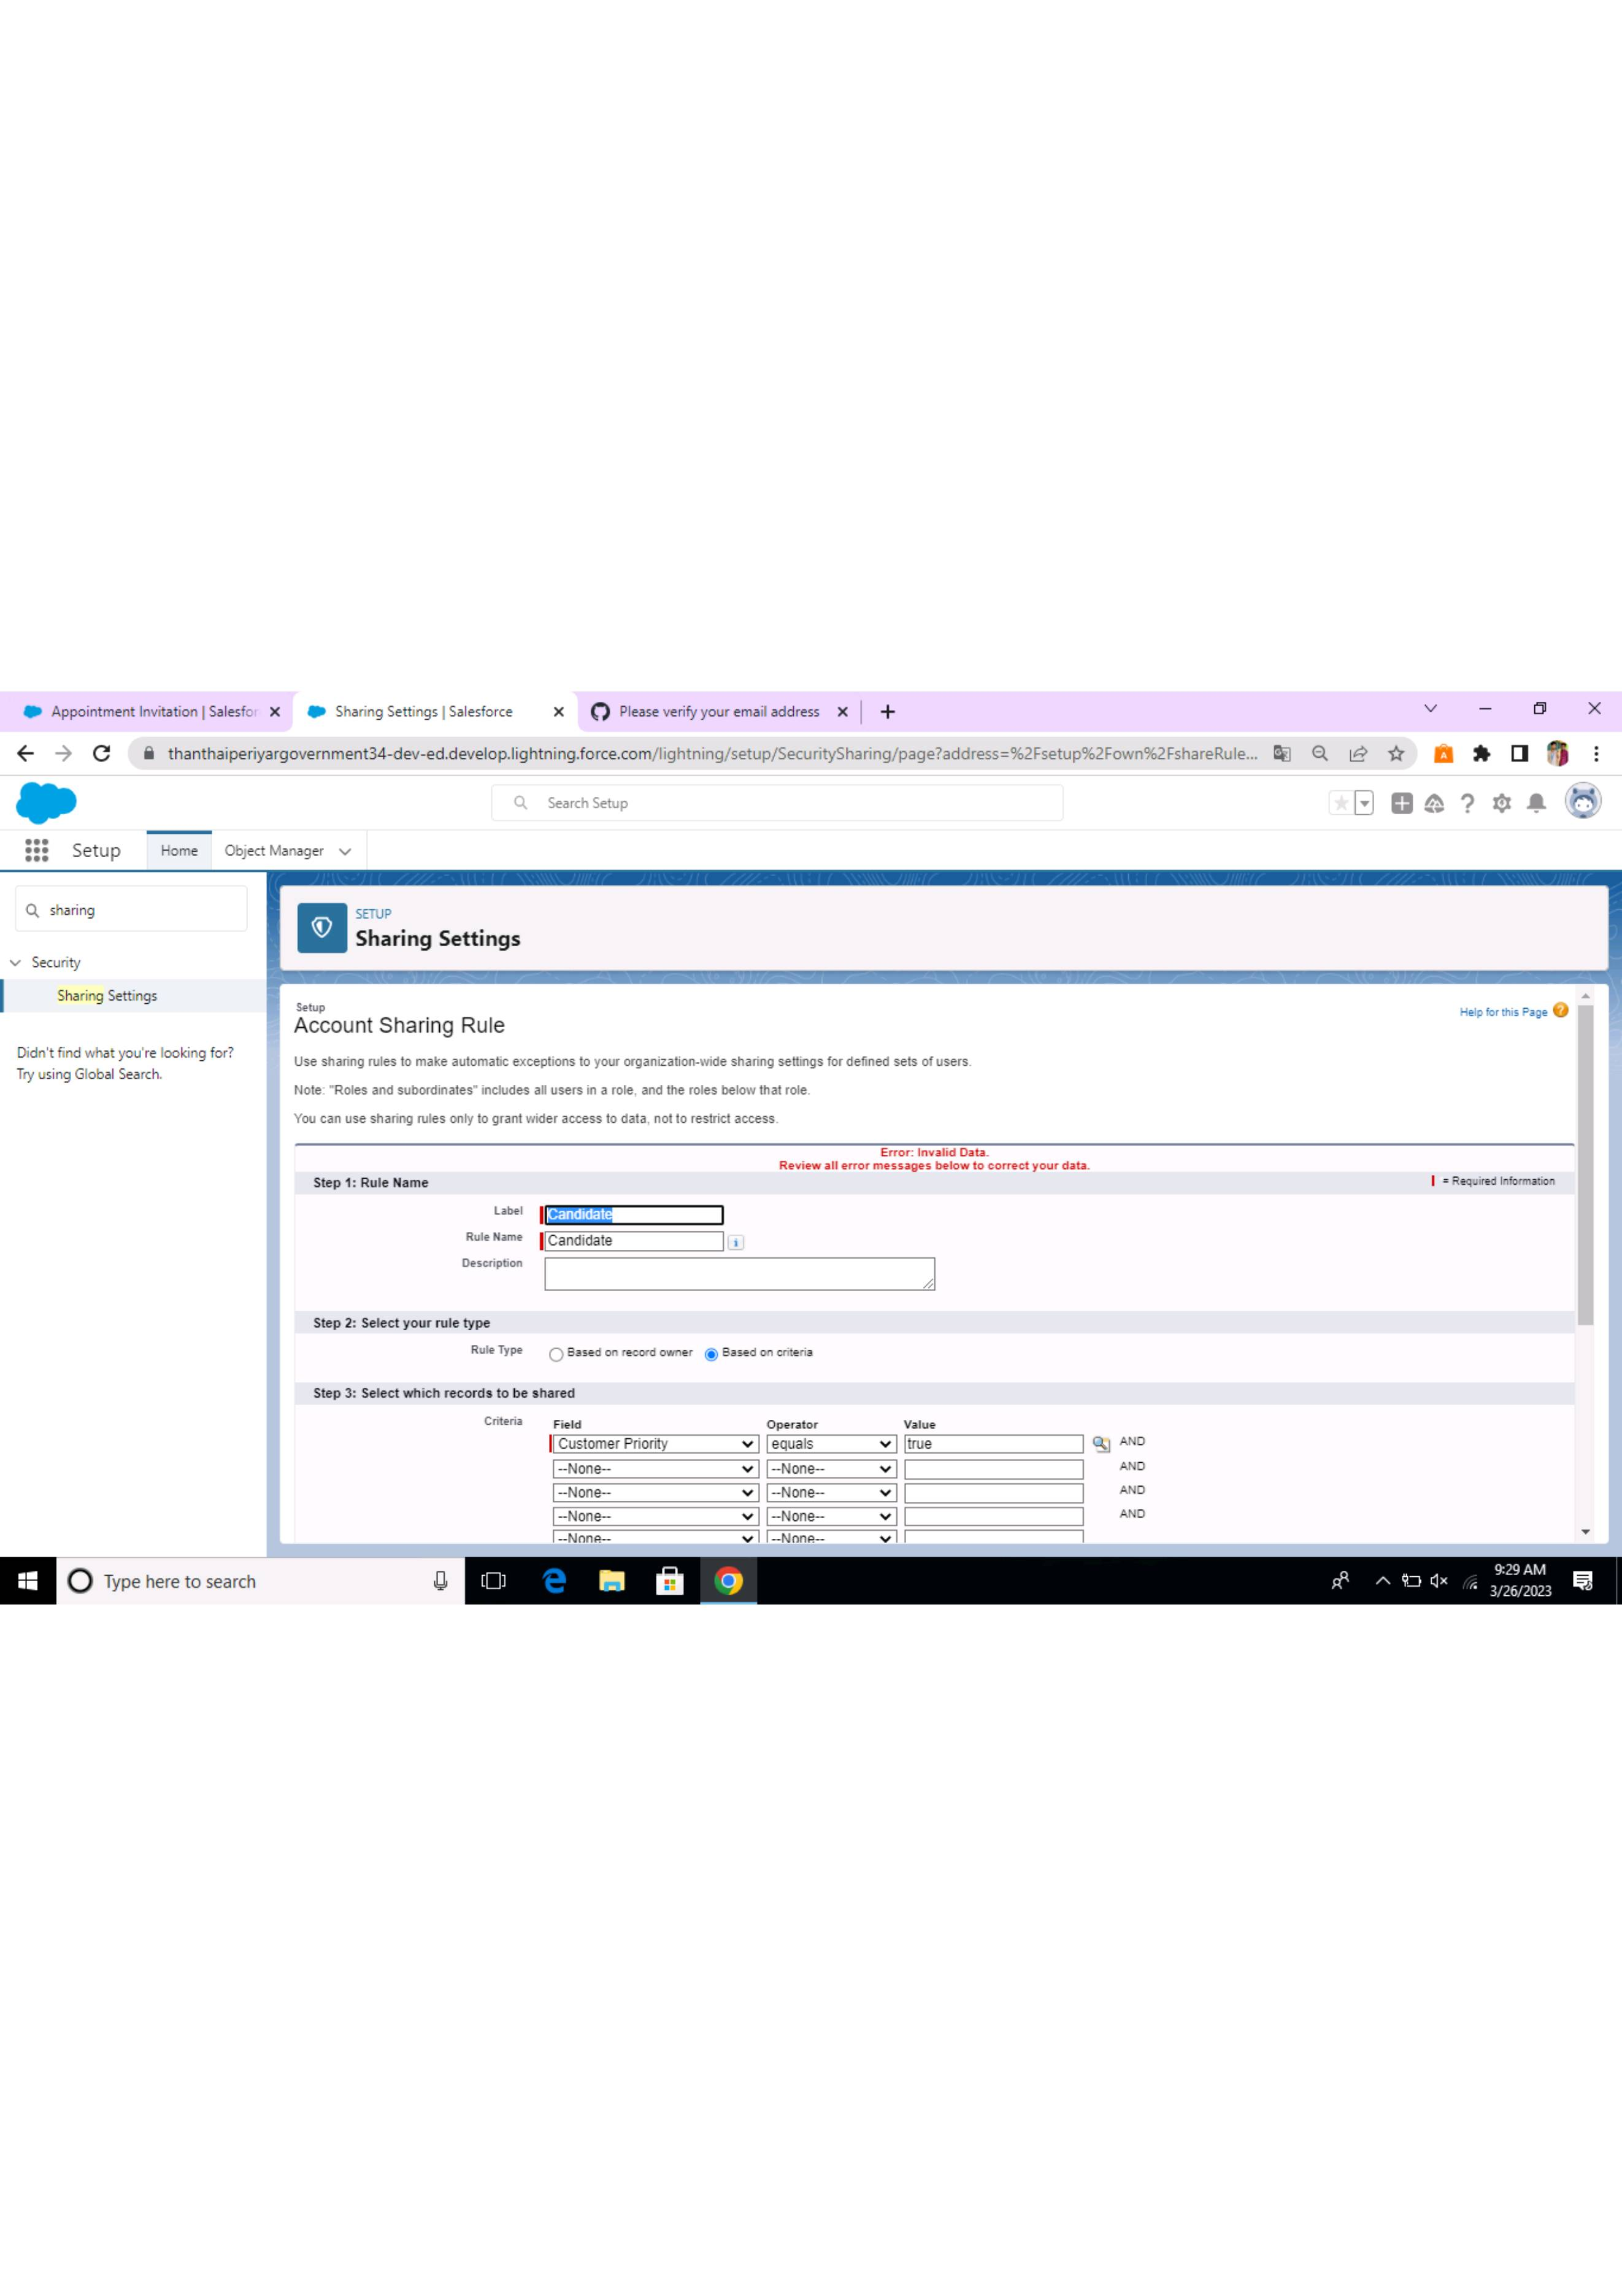

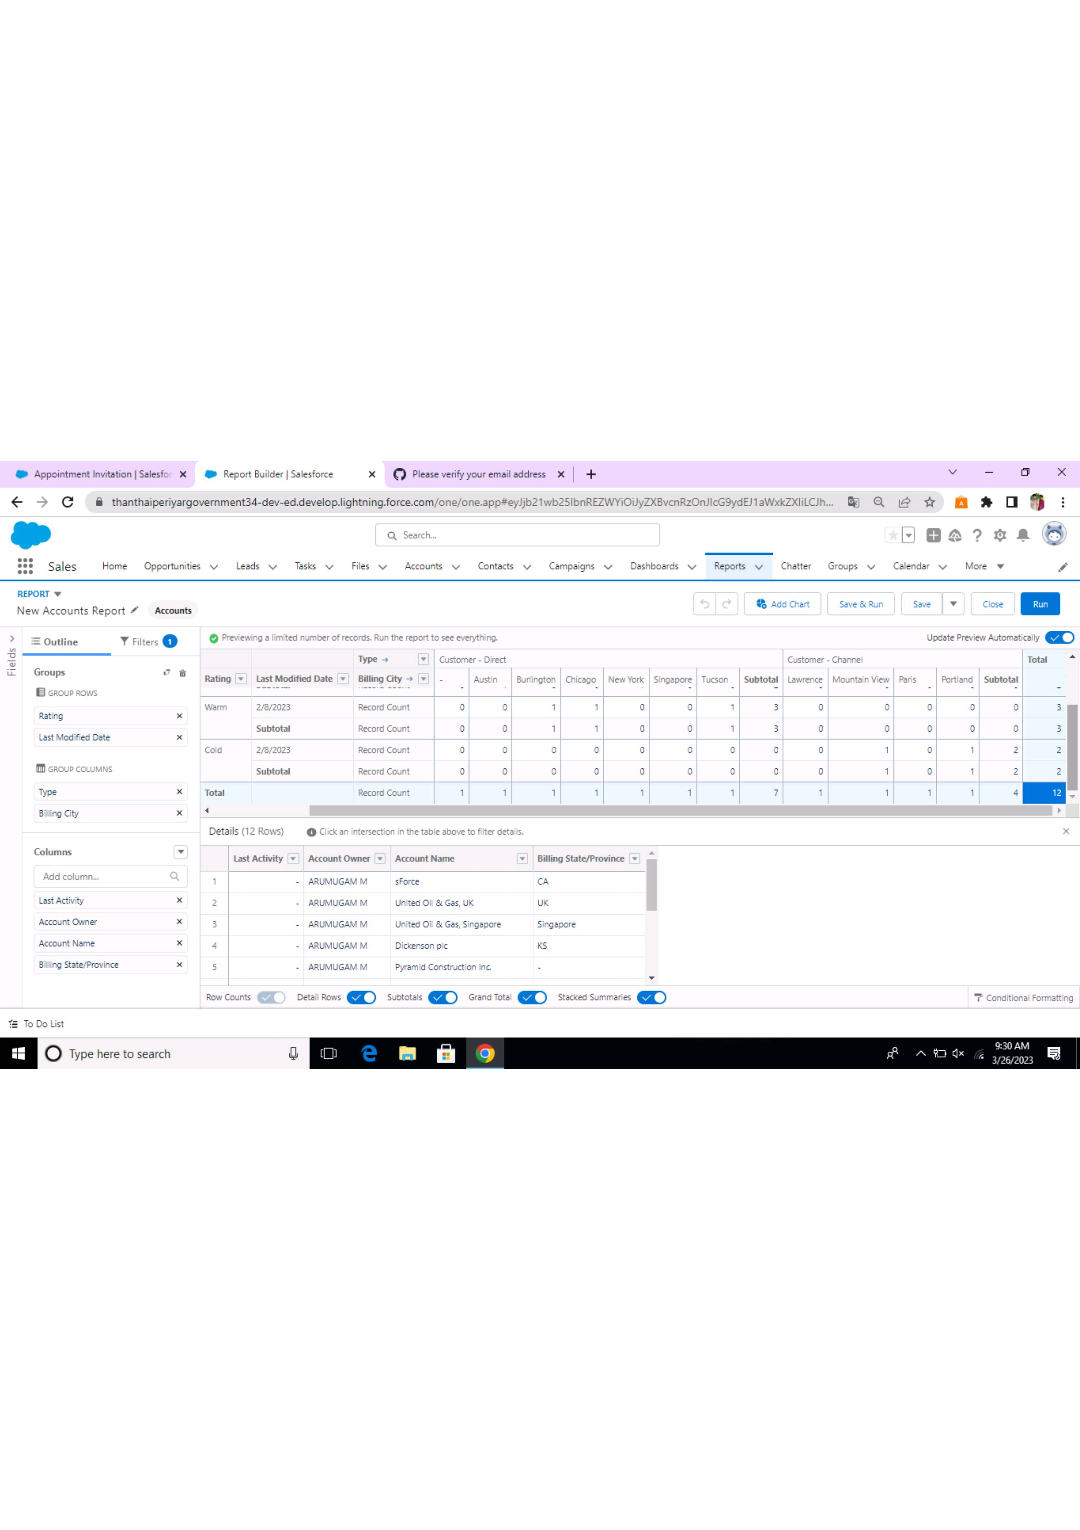

**4 Trailhead Profile Public URL**

Team Lead – <https://trailblazer.me/id/hsugumar>

Team Member 1 – <https://trailblazer.me/id/nrasu5>

Team Member 2 – <https://trailblazer.me/id/lmurugesan4>

Team Member 3 – <https://trailblazer.me/id/lsanjuvgandhi>

Team member 4 – <https://trailblazer.me/id/mkumar2839>

**5 ADVANTAGES & DISADVANTAGE**

**ADAVNTAGES**

1. Opportunity for creativity
2. Ability to work on different events
3. Chance to work with diverse clients
4. Collaborate work environment
5. High projection for job growth

**DISADVANTAGES**

1. Unconventional work hours
2. Time away from family and friends
3. Experience requirements
4. Job instability
5. Multiple events at the same time

**6 APPLICATIONS**

1. Assessing risks and developing a plan
2. Building the security team
3. Controlling access
4. Managing transportation and traffic
5. Managing administrative and logistical needs
6. Informing and staying informed

**7 CONCLUTION**

* Event Management system is user friendly and cost effective system, it is customized with activities related to event management life-cycle. It provides a new edge to management industry. Solution dot always keep your objectives and goals on top priority while developing any plan of work.

**8 FUTURE SCOPE**

1. Flexibility
2. Negotiation
3. Time management
4. Communication skills
5. Critical thinking
6. Customer relationship
7. Teamwork